18.FOOD ORDER SYSTEM

DEPLOYMENT DIAGRAM

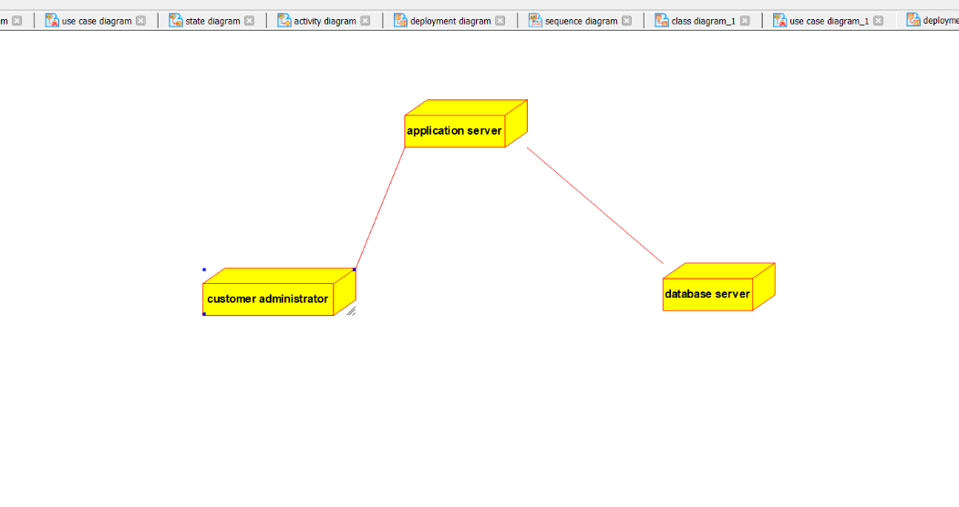

ACTIVITY DIAGRAM

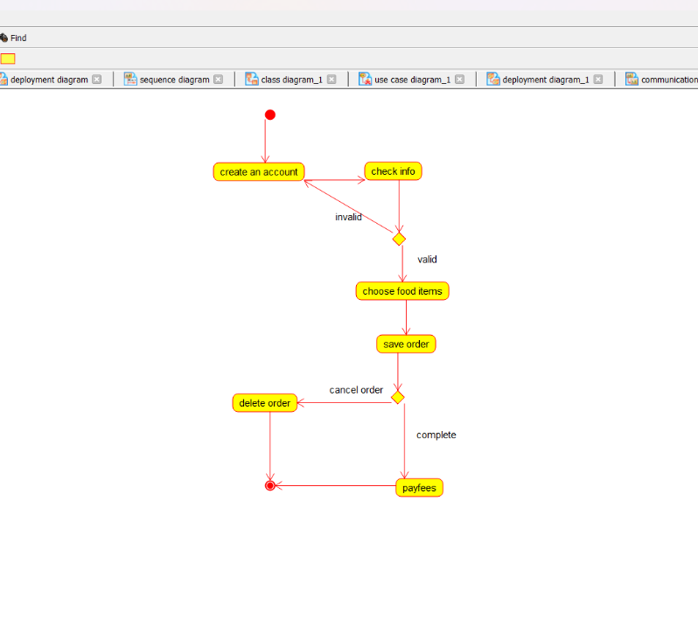

USE CASE DIAGRAM

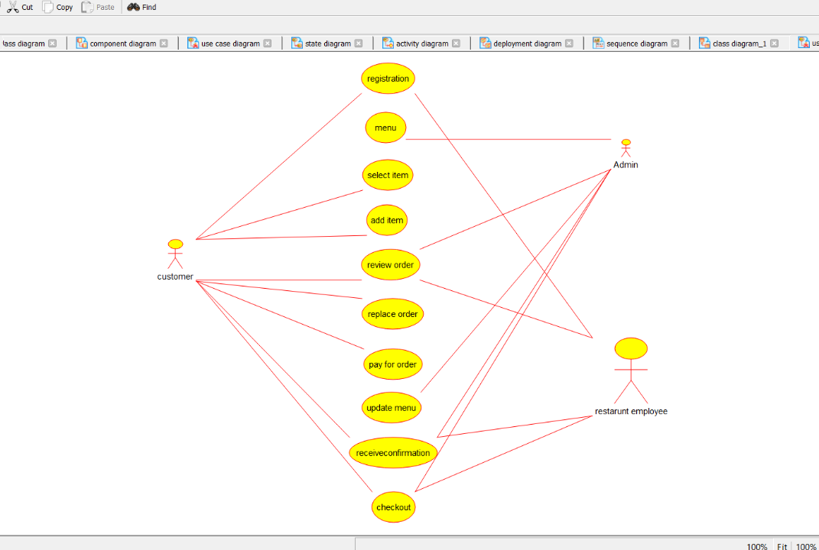

COLLABORATION DIAGRAM

